Date:19.09.25
TASK:7

Implementation of Monkey Banana Problem in Goal Stack planning using python by applying following constraints.

Implementation of Monkey Banana Problem in Goal Stack planning using python by applying following constraints.
Imagine a room containing a monkey, chair and some bananas. That have been hanged from the centre of ceiling. If the monkey is clever enough, he can reach the bananas by placing the chair directly below the bananas and climb on the chair. The problem is to prove the monkey can reach the bananas. The monkey wants it, but cannot jump high enough from the floor. At the window of the room there is a box that the monkey can use. The monkey can perform the Following actions: -
1) Walk on the floor.
2) Climb the box.
3) Push the box around (if it is beside the box).
4) Grasp the banana if it is standing on the box directly under the banana.
Tools: Python

PROBLEM STATEMENT: CO3 S3

In a tall room, a mischievous monkey is standing on the ground at position 0. A bunch of bananas is hanging from the ceiling at position 1, just out of the monkey’s reach, while a sturdy box is placed at position 2. The monkey has the ability to move between positions, push the box to a desired location, and climb onto the box to reach higher places. By carefully planning its actions—moving, pushing the box under the bananas, climbing on top of it, and finally grabbing the bananas—the monkey can successfully achieve its goal of getting the bananas.

IMPLEMENTATION OF MONKEY BANANA PROBLEM
IN GOAL STACK PLANNING
AIM
To Implement the Monkey Banana Problem in Goal Stack planning using python

ALGORITHM
- Initialize the environment
- Place the monkey at position 0.
- Place the bananas at position 1 (ceiling).
- Place the box at position 2.
- Check the goal
- If the monkey already has the bananas, stop.
- Otherwise, continue with the following actions.
- Move the monkey to the box
- If the monkey is not at the same position as the box, move it there.
- Push the box under the bananas
- Once at the box, push the box to the bananas’ position (position 1).
- The monkey moves together with the box.
- Climb onto the box
- If the monkey is at the same position as the box, climb on top of it.
- Grab the bananas
- If the monkey is on top of the box and the box is at the bananas’ position, grab the bananas.
- Goal achieved
- Monkey has successfully obtained the bananas.

PROGRAM
Monkey and Bananas Program

class MonkeyBananaProblem:
def __init__(self):
self.monkey_pos = 0 # Monkey starts at position 0
self.box_pos = 2 # Box is at position 2
self.banana_pos = 1 # Bananas are at position 1 (ceiling)
self.on_box = False
self.has_bananas = False

def move(self, pos):
print(f"Monkey moves from {self.monkey_pos} to {pos}")
self.monkey_pos = pos

def push_box(self, target_pos):
if self.monkey_pos == self.box_pos:
print(f"Monkey pushes box from {self.box_pos} to {target_pos}")
self.box_pos = target_pos
self.monkey_pos = target_pos
else:
print("Monkey must be at the box’s position to push it!")

def climb_box(self):
if self.monkey_pos == self.box_pos:
print("Monkey climbs onto the box")
self.on_box = True
else:
print("Monkey must be at the box to climb it!")

def grab_bananas(self):
if self.on_box and self.box_pos == self.banana_pos:
print("Monkey grabs the bananas! ")
self.has_bananas = True
else:
print("Monkey cannot reach the bananas yet!")

def solve(self):
print("--- Monkey and Bananas Problem ---")
# Step 1: Move to box at pos 2
self.move(2)
# Step 2: Push box to pos 1 (under bananas)
self.push_box(1)
# Step 3: Climb box
self.climb_box()
# Step 4: Grab bananas
self.grab_bananas()

if self.has_bananas:
print("Goal achieved : Monkey has the bananas!")
else:
print("Goal not achieved ")

# Run Simulation
problem = MonkeyBananaProblem()
problem.solve()

OUTPUT

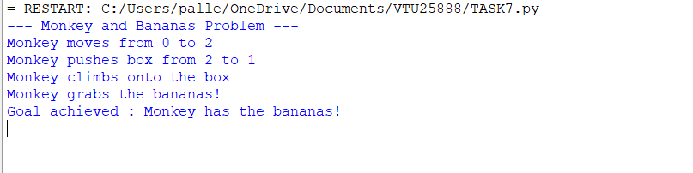

RESULT
Thus, the Implementation the Monkey Banana Problem in Goal Stack planning using python was successfully executed and output was verified.

